Low-Level Design (LLD): CI/CD Workflow and Change Governance
GCP Help Desk Chatbot Platform
Continuous Integration and Continuous Delivery - Low-Level Design

Document | CI/CD Workflow and Change Governance (LLD)
Version | 1.0
Date | 06 July 2026
Status | Draft for Review
Table of Contents
1. Document Control and Overview 4
1.1 Core System Actors and Components 4
2. Continuous Integration (CI) Phase 5
2.1 Source Control and Repository Topology 5
2.2 Pipeline Triggers 5
2.3 Reusable Workflows 6
2.4 Reproducible Build Environment (Nix devenv) 6
2.5 Task Orchestration (Taskfile) 6
2.6 Self-hosted Runners and Build Caching 6
2.7 CI Stage Sequence 7
2.8 Artifacts Produced 7
2.9 Secrets and Permissions 7
2.10 CI to CD Handoff 7
3. Trusted Promotion (CI to CD Bridge) 8
4. Deployment Orchestration (Armada) 9
5. Change Governance (ServiceNow ITIL) 10
6. Deployment Execution 11
6.1 Branch A: Ansible Tower CD Pipeline (GCP Infrastructure) 11
6.2 Branch B: CD Jenkins Pipeline (GKE Application) 11
7. Post-Deployment Closure and Observability 12
7.1 Callback Loops and Asset Synchronisation 12
7.2 Runtime Observability (Asynchronous Tracking) 12
2. CICD Diagram 13
Document Index
A section-by-section guide to the topics covered in this document.
Section | What it covers
1. Document Control and Overview | Purpose, scope and the actors/components that make up the delivery pipeline.
2. Continuous Integration (CI) Phase | How a GitHub code change becomes validated, versioned artifacts through GitHub Actions, reusable workflows, the Nix build environment, Taskfile steps and Nexus upload.
3. Trusted Promotion (CI to CD Bridge) | Security scanning, signing and promotion of artifacts from staging into the trusted registry.
4. Deployment Orchestration (Armada) | How releases are registered and driven through the Armada GUI, CLI and API.
5. Change Governance (ServiceNow ITIL) | Creation, readiness verification and isolation of the parent Change Request and per-target Change Tasks.
6. Deployment Execution | The Ansible Tower (infrastructure) and Jenkins (GKE application) rollout branches.
7. Post-Deployment Closure and Observability | Callbacks, CMDB synchronisation, Change Request closure and asynchronous progress tracking.
2. CICD Diagram | Diagram depicting the flow of CICD process

1. Document Control and Overview
This Low-Level Design describes the end-to-end delivery pipeline for the GCP Help Desk Chatbot platform. It is organised to follow the natural flow of a change: it begins with Continuous Integration (how a code change in GitHub becomes validated, versioned artifacts) and then moves into Continuous Delivery (how those artifacts are promoted, governed and deployed onto GCP and GKE). Each stage is broken down component by component, describing the responsibility of the component, the tooling behind it, and the inputs and outputs that connect it to the next stage.
The pipeline enforces repository-level code validation, reproducible builds, trusted-artifact promotion with security scanning, ServiceNow ITIL change compliance, and multi-tenant cloud environment orchestration across Development, Certification and Production.

1.1 Core System Actors and Components
Developer: Authors code and triggers the pipeline through commits, pull requests, or manual workflow runs.
GitHub and GitHub Actions: The source-control system and the CI engine that build, test and package artifacts using shared reusable workflows.
Nexus Repositories: The artifact stores. Nexus Dev (staging) receives freshly built artifacts; Nexus Trusted holds security-cleared, promotion-ready artifacts.
Security and Compliance Gates: Prisma Cloud (container and IaC compliance) and, where enabled, static and composition scanners that vet artifacts before promotion.
Orchestration (Armada): The release-orchestration layer, exposed through the Armada GUI, the NGP Toolbox CLI and the Armada API, backed by the Armada DB.
Change Governance (ServiceNow): The system of record for ITIL change control, managing the parent Change Request (CR) and the per-target Change Tasks (CTasks).
Deployment Pipelines: The Ansible Tower CD Pipeline provisions GCP infrastructure via Terraform; the CD Jenkins Pipeline delivers containers to GKE.
Destination Footprints: The target GCP Projects and GKE Clusters for Development, Certification and Production.

2.CICD Diagram

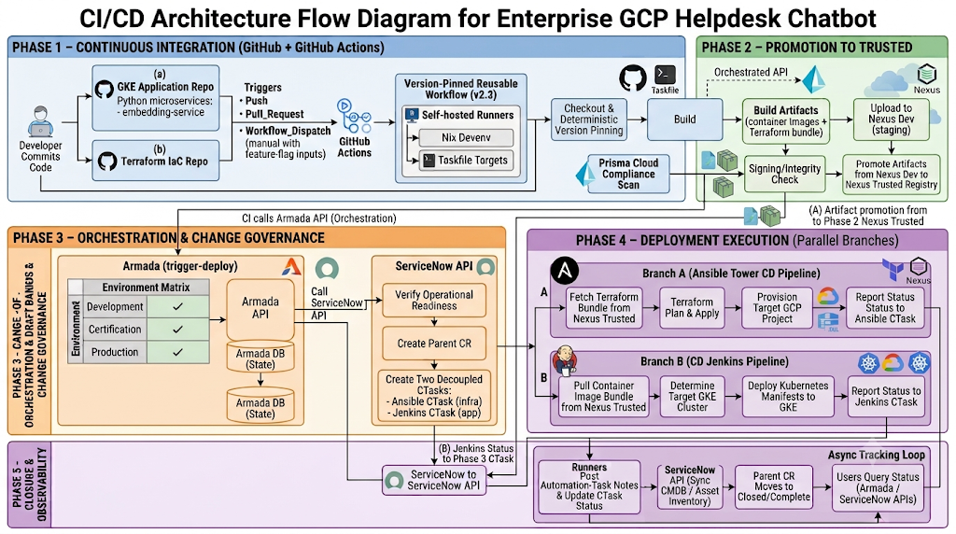

3. Continuous Integration (CI) Phase
Continuous Integration turns a developer change in GitHub into validated, versioned, security-ready artifacts staged in Nexus. The CI phase owns everything from source checkout through artifact upload and the trusted-promotion trigger; it ends the moment a deployment request is handed to Armada.
GitHub commit -> GitHub Actions -> Reusable Workflow (Nix devenv + Taskfile) -> Build -> Artifacts (images + Terraform bundle) -> Nexus Dev -> Trusted Promotion -> Nexus Trusted -> trigger-deploy (Armada)

3.1 Source Control and Repository Topology
The source of truth lives in two independent GitHub repositories, each owning a distinct deliverable and its own pipeline definition under .github/workflows.
ecs.hd-chatbot-platform-gke (Application repository): Holds the one runtime microservices, the embedding-service and the Cloud Function (ServiceNow integration), each with its own Python source, requirements manifest and Dockerfile. It also carries the Kubernetes delivery assets, a Helm chart under configuration/files/helm (templates for deployment, service, HPA, PDB, config maps, secrets and virtual service) and per-environment values for GCP-Dev, GCP-Cert, GCP-CI and GCP-Prod. CI for this repository produces two container images.
ecs.hd-chatbot-platform-terraform (Infrastructure-as-Code repository): Its Terraform root module composes child modules for every GCP building block the platform needs, including agent_engine (Vertex AI ADK agents), cloud_composer, cloud_function, firestore, gcs, memorystore, secret_manager, service_account, vector_search and workload_identity. CI for this repository validates the configuration and produces a versioned Terraform bundle plus packaged agent source archives.

3.2 Pipeline Triggers
Each repository starts its GitHub Actions workflow on three event types, giving both automatic and controlled entry points into CI:
push: Every push runs build and packaging; a push to the default branch additionally triggers an automatic Development deployment, making main a continuously deployable branch.
pull_request: Validates a proposed change (build and packaging) before merge, acting as a pre-merge quality gate.
workflow_dispatch: A manual run exposing granular boolean inputs (for example executeDevDeployment, executePromotion, executeStpDeployment and executeAcceptanceTests) so an operator can selectively enable heavier or optional stages for a specific run.
A concurrency group keyed on the workflow and branch, with cancel-in-progress enabled, ensures that a newer commit supersedes any in-flight run for the same branch, preventing wasted runner time and race conditions.

3.3 Reusable Workflows
Neither repository defines build logic inline. Each workflow delegates to a shared, version-pinned reusable workflow owned by the platform team, which standardises the CI contract across the whole organisation:
The GKE application repository calls reusable-gke-container-nix.yaml (pinned at v2.3) from sabre-internal/gh-core.common-ci-components.
The Terraform repository calls reusable-terraform-nix.yaml (pinned at v2.3) from the same shared components repository.
The calling workflow supplies configuration through the with block (runner, timeout, cache bucket, feature-flag steps) and passes credentials through the secrets block. Pinning to an explicit tag guarantees that pipeline behaviour only changes through a deliberate version bump, not silently.

3.4 Reproducible Build Environment (Nix devenv)
The reusable workflows execute inside a Nix devenv defined by devenv.nix and devenv.yaml, which pins the exact toolchain so a build is byte-for-byte reproducible on any runner. The environment provides utilities such as envsubst, j2cli, zip and podman. Podman is aliased to docker so container image builds succeed without a Docker daemon present. This eliminates the works-on-my-machine class of build failure.

3.5 Task Orchestration (Taskfile)
Repository-specific build behaviour is expressed as Task targets in taskfile.yaml, which the reusable workflow invokes at well-defined hook points. This keeps the shared CI contract stable while letting each repository customise its own steps. Key targets include:
get-application-version: Derives the deterministic version string used consistently by build, upload and promotion.
release-embedding-image: Build, verify and push the embedding microservice container image to Nexus.
upload-configuration / upload-terraform: Publish the Helm chart or the Terraform bundle to the Nexus staging repository.
scan-to-trusted: Runs the security and compliance scan and promotes clean artifacts into the trusted zone.
trigger-deploy: Emits the deployment request, with its environment matrix, to Armada.

3.6 Self-hosted Runners and Build Caching
Builds run on self-hosted runners (runner class ecs-common-m) with a generous job timeout (90 minutes) suitable for container and Terraform workloads. To keep repeat builds fast, the pipeline uses an HMAC-signed remote cache bucket (cache_bucketName); the HMAC access key and secret are supplied as workflow secrets so cache reads and writes are authenticated.

3.7 CI Stage Sequence
The reusable workflow executes a fixed, feature-flag-controlled sequence. For each stage the corresponding steps_execute input decides whether it runs:
1. Checkout and Version Pinning: The exact source revision is checked out and a deterministic application version is derived. For the GKE repository this combines the normalised branch name with the GitHub run number and run attempt (offset by IMAGE_TAG_OFFSET); for the Terraform repository it is the twelve-character short commit SHA. The same coordinates are reused downstream so every artifact is traceable back to a single commit.
2. Build: Dependencies are resolved inside the Nix environment and the deliverable is assembled. For Terraform this runs terraform init and terraform validate (after packaging the ADK agent archives); for the GKE services it prepares the container build context.
3. Artifact Assembly: The GKE pipeline builds the embedding-image container; the Terraform pipeline assembles the validated Terraform bundle and agent source archives.
4. Upload to Nexus Dev: Artifacts are published first to the Development (staging) Nexus repository at repository.sabre-gcp.com, together with the Helm configuration chart for the application repository.
5. Promotion Trigger: On a clean build the pipeline proceeds to trusted promotion (Section 3), and, on a default-branch push or an explicit opt-in, issues the deployment trigger to Armada (Section 4).

3.8 Artifacts Produced
The GKE repository produces one OCI container image, the embedding-image, pushed to repository.sabre-gcp.com:9082 under sabre/helpdesk/chatbot, plus a versioned Helm chart describing the Kubernetes deployment. The Terraform repository produces a versioned Terraform bundle and per-agent source archives that the agent_engine module consumes at plan time. Every artifact carries the deterministic version so upload, promotion and deployment all reference identical coordinates.

3.9 Secrets and Permissions
All credentials are injected from GitHub Actions Secrets and never committed to the repositories: repository read credentials (RO_APP_ID and RO_APP_PEM), Nexus credentials, promotion Jenkins credentials, cache HMAC keys, the Armada API token, the Terraform Enterprise token, and downstream service secrets such as the ServiceNow URL, username and password. Workflow permissions are scoped following least privilege (contents write, checks write, pull-requests write, with read-only access elsewhere).

3.10 CI to CD Handoff
CI concludes when trusted artifacts exist in Nexus Trusted and a trigger-deploy call reaches Armada carrying the environment matrix. For the application this matrix spans the Development, Certification and Production GCP projects and their GKE clusters; for Terraform it spans the corresponding chatbot GCP projects. From this point ownership shifts from build-and-release preparation to governed runtime deployment.

4. Trusted Promotion (CI to CD Bridge)
Before any artifact can be deployed it must cross from the staging zone into the trusted zone. The scan-to-trusted step pulls the staged artifact and runs a Prisma Cloud compliance scan (container and infrastructure checks), orchestrated through the Armada API. Only artifacts that pass with a clean payload are signed, integrity-verified and replicated into the Nexus Trusted registry. This boundary guarantees that every artifact reaching a cluster has been security-vetted and is probably the same artifact that was built in CI.

5. Deployment Orchestration (Armada)
Armada is the release-orchestration layer that bridges trusted artifacts and environment execution. A deployment request must be registered with Armada before it can run, and Armada accepts these requests across three channels:
Manual Ingress: Through the web-based Armada GUI (armada.sabre-gcp.com).
CLI Ingress: Through the NGP Toolbox CLI executing the trigger-deploy command with its metadata.
API Ingress: Through direct headless calls to the Armada API (armada-api.sabre-gcp.com), which is how the CI pipeline hands off.
The Armada API commits the operational state to the Armada DB and retrieves runtime metadata to assemble the final deployment record, which then drives the change-governance step.

6. Change Governance (ServiceNow ITIL)
No environment deployment may execute without passing through a synchronised, audited change-management gate in ServiceNow. Armada drives this gate through the ServiceNow API:
Armada API -> ServiceNow API -> Verify Operational Readiness -> Create Parent CR -> [Ansible CTask (infra)] + [Jenkins CTask (app)]

CR Creation: The Armada API calls the ServiceNow API to auto-generate a parent Change Request (CR) capturing the release identity and deployment context.
Readiness Verification: The ServiceNow engine programmatically evaluates operational-readiness rules and verifies policy approvals against the target environments.
Targeted CTask Isolation: Based on the destination parsed from the ingestion metadata, ServiceNow creates decoupled Change Tasks so each footprint is tracked independently: an Ansible CTask governing infrastructure (GCE) steps, and a Jenkins CTask governing the application microservice (GKE) rollout.

7. Deployment Execution
Once ServiceNow clears approvals it releases the targeted CTasks, shifting ownership to runtime execution. The two branches run against their respective footprints.

7.1 Branch A: Ansible Tower CD Pipeline (GCP Infrastructure)
Artifact Retrieval: The playbook fetches the validated Terraform bundle from the Nexus Trusted repository (with a three-retry tolerance) and concurrently retrieves supporting artifacts from the trusted registry.
Cloud Provisioning: Ansible Tower runs concrete terraform plan and terraform apply sequences directly against the target destination GCP Project.
State Reporting: The execution engine streams live playbook-status callbacks back to the specific Ansible CTask so progress is auditable in ServiceNow.

7.2 Branch B: CD Jenkins Pipeline (GKE Application)
Artifact Retrieval: The shared CI/CD Jenkins engine pulls the compiled container image bundle from Nexus Trusted.
Cluster Orchestration: The pipeline runs cluster-discovery steps to determine the correct target GKE cluster and namespace.
Atomic Rollout: The engine deploys the Kubernetes manifests, using the configured blue-green strategy, into the live destination GKE cluster nodes, and reports status back to the Jenkins CTask.

8. Post-Deployment Closure and Observability

8.1 Callback Loops and Asset Synchronisation
On completion the active runner establishes a secure callback to the system of record: detailed log output is posted through addAutomationTaskNotes, and atomic status is delivered through updateAutomationTaskStatus to mark the CTask Completed. ServiceNow then runs automated CMDB synchronisation to update the configuration-item registry with the new infrastructure state, and once all automation tasks finish it moves the parent Change Request to Closed / Complete.

8.2 Runtime Observability (Asynchronous Tracking)
Teams can audit pipeline progress asynchronously through two tracks: the Armada Tracking Path, where users query execution state via the Armada API which links internally to CR status in ServiceNow; and the Direct ServiceNow Path, where users hit the ServiceNow API to monitor human-readable logs and granular CTask status attributes.

